**EARTH QUAKE PREDICTION MODEL USING PYTHON**

**Problem Definition:**

In this article, I will take you through how to create a model for the task of Earthquake Prediction using Machine Learning and the Python programming language. Predicting earthquakes is one of the great unsolved problems in the earth sciences.

**Design Thinking:**

**Data Source:**

## **Abstract**

Earthquakes are one of the most catastrophic natural phenomena. After an earthquake, earthquake reconnaissance enables effective recovery by collecting data on building damage and other impacts. This paper aims to identify state-of-the-art data sources for building damage assessment and provide guidance for more efficient data collection.

We have reviewed 39 articles that indicate the sources used by different authors to collect data related to damage and post-disaster recovery progress after earthquakes between 2014 and 2021.

The current data collection methods have been grouped into seven categories: fieldwork or ground surveys, omnidirectional imagery (OD), terrestrial laser scanning (TLS), remote sensing (RS), crowdsourcing platforms, social media (SM) and closed-circuit television videos (CCTV).

The selection of a particular data source or collection technique for earthquake reconnaissance includes different criteria depending on what questions are to be answered by these data. We conclude that modern reconnaissance missions cannot rely on a single data source.

Different data sources should complement each other, validate collected data or systematically quantify the damage. The recent increase in the number of crowdsourcing and SM platforms used to source earthquake reconnaissance data demonstrates that this is likely to become an increasingly important data source

## **1. Introduction**

Each year, disasters cause significant human and economic losses. Out of these disasters, earthquakes are one of the most catastrophic natural phenomena. These events have caused more than 23 million deaths between 1902 and 2011 [[**1**](https://www.mdpi.com/2673-4834/2/4/60#B1-earth-02-00060)], substantial physical, social, economic [[**2**](https://www.mdpi.com/2673-4834/2/4/60#B2-earth-02-00060)] and, occasionally, institutional, cultural and environmental losses.

Following an earthquake, there is a substantial demand and need for spatial information [[**1**](https://www.mdpi.com/2673-4834/2/4/60#B1-earth-02-00060),[**2**](https://www.mdpi.com/2673-4834/2/4/60#B2-earth-02-00060)] about population location [[**3**](https://www.mdpi.com/2673-4834/2/4/60#B3-earth-02-00060)], evacuation routes, availability of resources [[**4**](https://www.mdpi.com/2673-4834/2/4/60#B4-earth-02-00060)], size of the affected area and distribution of damage. Later, during the emergency phase, it is necessary to collect more detailed data about damages in the structural components of buildings [[**5**](https://www.mdpi.com/2673-4834/2/4/60#B5-earth-02-00060)].

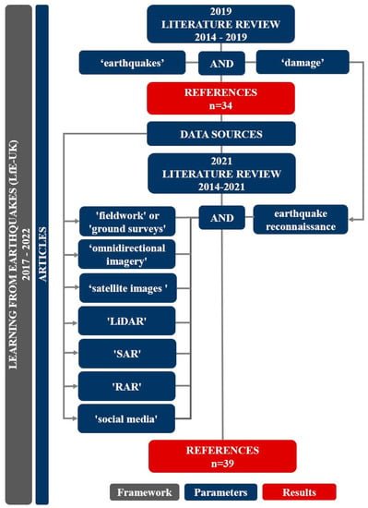

**Figure 1.** Flow diagram of the methodology applied to select the references for the literature review.

The references were identified from the Web of Science in both literature reviews because we consider it the most comprehensive curated database available. While we reviewed and included the references published in 2014 and 2015 that were identified in the first literature review, we have not counted them because we aim to highlight the state-of-the-art (last five years). The search was conducted between February 2019 and June 2021. In the literature review undertaken at the beginning of the project, we reviewed references published between 2014 and 2019. At the end of the project, we reviewed references bublished. .

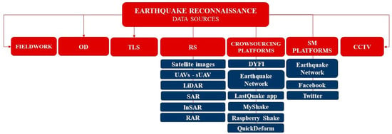

**Figure 2.** Earthquake reconnaissance data sources.

**Table 1.** Summary of references reviewed for this literature review.



Missions deployed, or missions that have had their results published during the period covered by this literature review, are Albania [[**38**](https://www.mdpi.com/2673-4834/2/4/60#B38-earth-02-00060),[**48**](https://www.mdpi.com/2673-4834/2/4/60#B48-earth-02-00060)], Puerto Rico [[**36**](https://www.mdpi.com/2673-4834/2/4/60#B36-earth-02-00060),[**37**](https://www.mdpi.com/2673-4834/2/4/60#B37-earth-02-00060)], Mayotte [[**43**](https://www.mdpi.com/2673-4834/2/4/60#B43-earth-02-00060)], Mexico [[**27**](https://www.mdpi.com/2673-4834/2/4/60#B27-earth-02-00060),[**49**](https://www.mdpi.com/2673-4834/2/4/60#B49-earth-02-00060),[**50**](https://www.mdpi.com/2673-4834/2/4/60#B50-earth-02-00060)], –North Sulawesi (Indonesia), Hualien (China) [[**42**](https://www.mdpi.com/2673-4834/2/4/60#B42-earth-02-00060)], central Italy [[**28**](https://www.mdpi.com/2673-4834/2/4/60#B28-earth-02-00060)], (Ecuador) [[**28**](https://www.mdpi.com/2673-4834/2/4/60#B28-earth-02-00060)], Nepal [[**15**](https://www.mdpi.com/2673-4834/2/4/60#B15-earth-02-00060),[**39**](https://www.mdpi.com/2673-4834/2/4/60#B39-earth-02-00060)], Napa—California (USA) [[**45**](https://www.mdpi.com/2673-4834/2/4/60#B45-earth-02-00060),[**51**](https://www.mdpi.com/2673-4834/2/4/60#B51-earth-02-00060)], Haiti [[**10**](https://www.mdpi.com/2673-4834/2/4/60#B10-earth-02-00060)] and L’Aquila (Italy) [[**12**](https://www.mdpi.com/2673-4834/2/4/60#B12-earth-02-00060),[**30**](https://www.mdpi.com/2673-4834/2/4/60#B30-earth-02-00060)]. The location of major earthquakes epicentres from 2014–2019 included as case studies in this literature review is depicted in [**Figure 3**](https://www.mdpi.com/2673-4834/2/4/60#fig_body_display_earth-02-00060-f003).

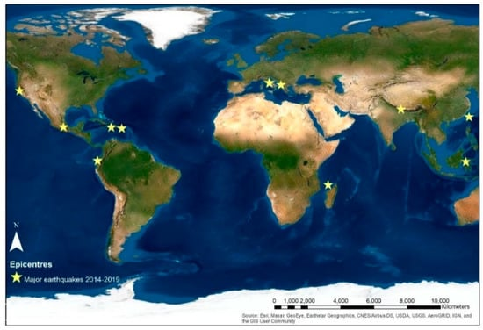

**Figure 3.** Spatial distribution of epicentres of major earthquakes that occurred from 2014–20

**Feature Exploration:**

Scientists estimate earthquake probabilities in two ways: by studying the history of large earthquakes in a specific area and the rate at which strain accumulates in the rock. Scientists study the past frequency of large earthquakes in order to determine the future likelihood of similar large s 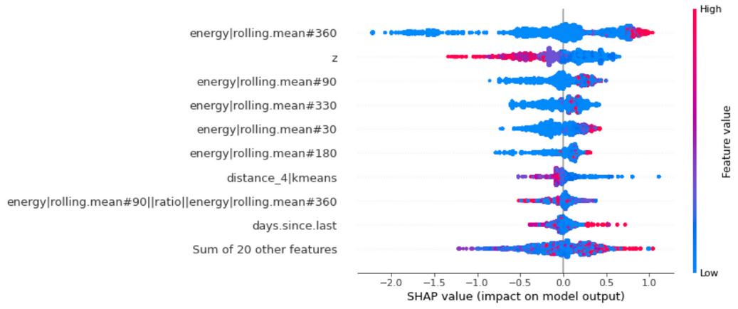

**Visualization:**

Visualize Earthquake Data in Python with earth quake data using the mat plop library of Python can provide valuable insights into the frequency, magnitude, and location of earthquakes, which can help in predicting and mitigating their impacts.

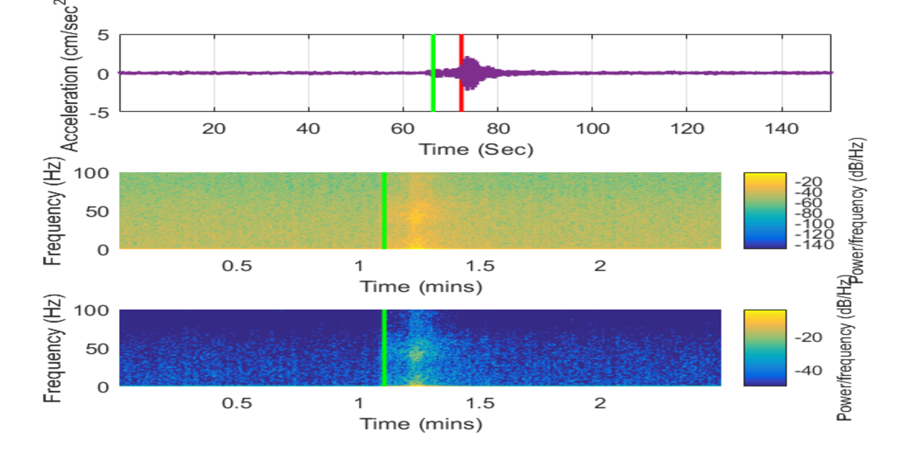

**Data Splitting:**

Most research on earthquake prediction uses machine learning (ML) algorithms with seismic indicators based on Gutenberg Richter's law and Omori's law. Several studies have required the observation of earthquake precursors to predict future occurrences.

**Model Development:**

In machine learning, regression is a type of supervised learning that involves predicting a continuous numeric output value based on input features. Regression models are commonly used to make predictions about future trends or values, such as predicting the number of gift cards that will be sold next month.

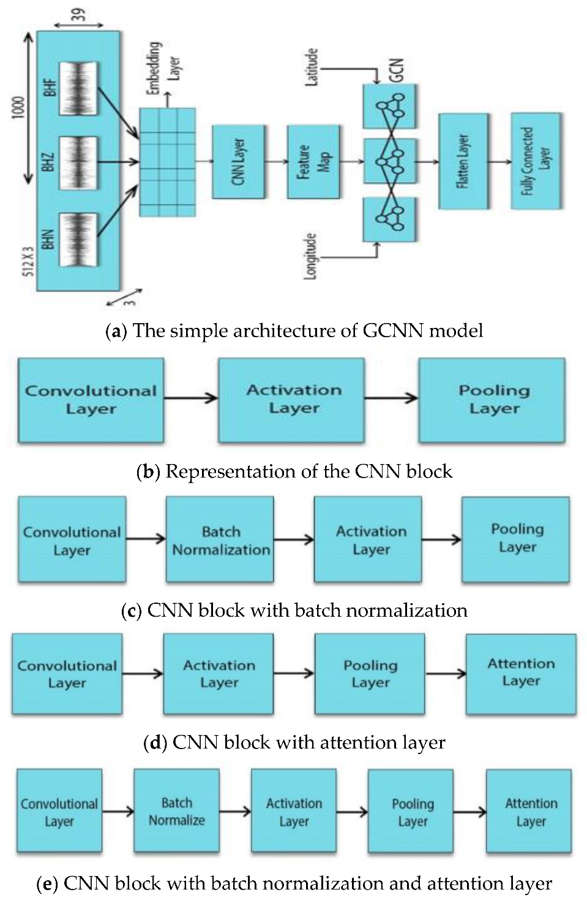

**Training and Evaluation:**

It is not currently possible to predict exactly when and where an earthquake will occur, nor how large it will be. However, seismologists can estimate where earthquakes may be likely to strike by calculating probabilities and forecasts.

